
Paper 4 Basic Python
Practice Questions

9618 Computer Science
Python Practice Questions for Paper 4 Preparation Basics Python Only
Note : These Questions are not your actual Paper 4 syllabus Questions but very important to master the basics of python
9618 Computer Science - 100 Questions
EASY LEVEL (Questions 1-35)
Print, Variables & Data Types (Q1-10)
Question 1
Write a program that prints "Hello, World!" on the screen.
Code
print("hello World!")

Terminal

Question 2
Create a variable called age and assign the value 17 to it. Print the value of age.
Code
Declare age : int
age = 17
print(age)

Terminal

Question 3
Declare two variables: firstName with value "Ahmed" and lastName with value "Khan". Print both variables.
Code
Declare firstname,lastname : Str
firstname = "Ahmed"
lastname = "Khan"
print(firstname + lastname)

Terminal
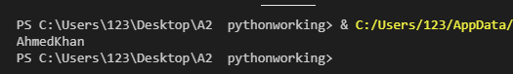

Question 4
Create a variable price with value 99.99. Use the type() function to print the datatype of this variable.
Code
Declare price : float
price = 99.99
print (type(price))

Terminal
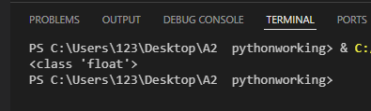

Question 5
Create a variable number with value 45.78. Convert it to an integer and print the result.
Code
Declare number :float
number = 45.78
print (int(number))

Terminal
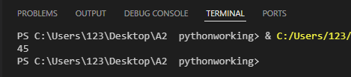

Question 6
Assign the value "123" (as a string) to a variable called numString. Convert it to an integer, add 10 to it, and print the result.
Code
# Declare numString : str
#Declare num :int
numString = "123"
num = int(numString) + 10
print (num)

Terminal
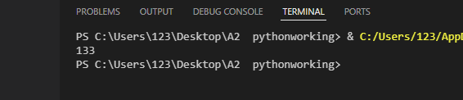

Question 7
Create three variables: a = 10, b = 20.5, c = "Hello". Print the datatype of each variable.
Code
a = 10
b = 20.5
c = "Hello"
print (type(a))
print (type(b))
print (type(c))

Terminal
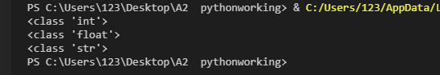

Question 8
Write a program that stores your school name in a variable and prints it with a welcome message.
Code
#Declare school :str
school = "Classic school system"
print ("Welcome to " + school)

Terminal
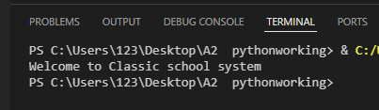

Question 9
Create a variable temperature with value 36.6. Print a message saying "The temperature is: " followed by the value.
Code
#Declare temprature :int
temprature = 36.6
print ("The temperature is :" + str(temprature))

Terminal
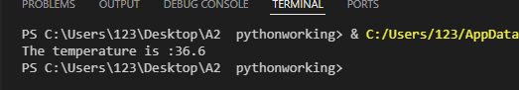

Question 10
Declare a variable year with value 2026. Print a message that says "Paper 4 exam year is: " followed by the year.
Code
#Declare year :str
year = "2026"
print ("Paper 4 exam year is" +" "+ year)

Terminal
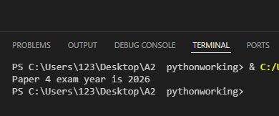

Mathematical Operations (Q11-18)
Question 11
Write a program that calculates and prints the sum of 25 and 75.
Code
print (25 + 75)

Terminal
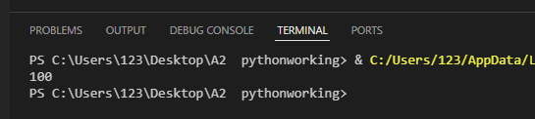

Question 12
Create two variables num1 = 100 and num2 = 35. Calculate and print their difference.
Code
#Declare num1,num2 : int
num1 = 100
num2 = 35
print (num1 - num2)

Terminal
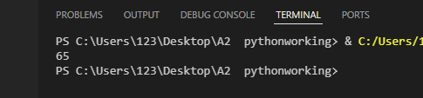

Question 13
Write a program that multiplies 12 by 8 and prints the result.
Code
#Declare num : int
num = 12
print (num / 8 )

Terminal
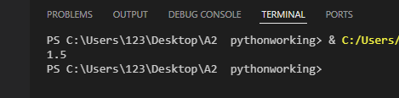

Question 14
Divide 150 by 4 and print the result.
Code
#Declare num : int
num = 150
print (num / 4 )

Terminal
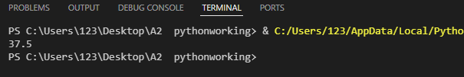

Question 15
Create variables length = 15 and width = 8. Calculate the area of a rectangle and print it.
Code
#Declare length, widht : int
length = 15
width = 8
print ("Area is ", length * width)

Terminal
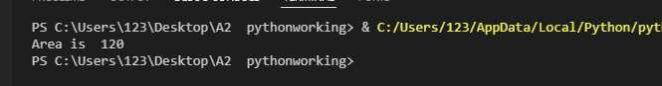

Question 16
Write a program that calculates the perimeter of a square with side length 25.
Code
#Declare length, square : int
length = 25
square = length * 4
print (square)

Terminal
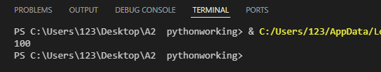

Question 17
Create a variable radius = 7. Calculate the area of a circle (use 3.14159 for pi) and print the integer part only.
Code
#Declare radius : int
#Declare pi,area : float
radius = 7
pi = 3.14159
area = pi * (radius*radius)
print (int(area))

Terminal
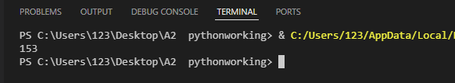

Question 18
Write a program that converts 5 kilometers to meters (multiply by 1000) and prints the result.
Code
#Declare meters : integer
meters = 1000
print (5 * meters)

Terminal
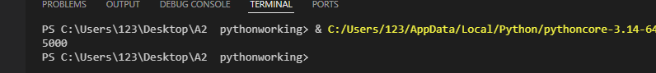

String Concatenation (Q19-22)
Question 19
Create two variables part1 = "Computer" and part2 = "Science". Concatenate them with a space in between and print the result.
Code
#Declare part1,part2: str
part1 = "Computer"
part2 = "Science"
print (part1 + " " + part2)

Terminal
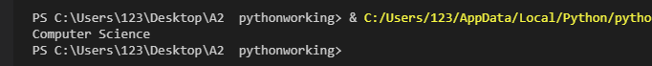

Question 20
Store your first name and last name in separate variables. Create a full name by concatenating them with a space and print it.
Code
#Declare firstname,lastname: string
firstname = "Choudhry"
lastname= "Aydoun"
print (firstname + " " + lastname)

Terminal
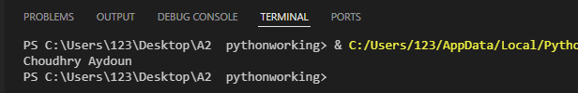

Question 21
Create variables city = "Karachi" and country = "Pakistan". Print them in the format "City: Karachi, Country: Pakistan" using concatenation.
Code
# Declare city ,country : String
city = "Karachi"
country = "Pakistan"
print ("City:"+ city + "," + "Country :" + country)

Terminal
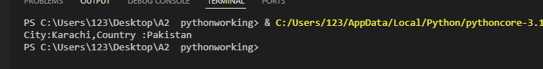

Question 22
Create a variable subject = "Python". Concatenate it with the string " is fun!" and print the result.
Code
# Declare subject ,feeling : String
subject = "Python"
feeling = "is fun! "
print(subject + " "+ feeling)

Terminal
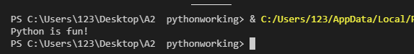

Input from User (Q23-28)
Question 23
Ask the user to enter their name and print "Hello, " followed by their name.
Code
# Declare name : String
name = input("Enter your name :")
print('Hello' + " " + name)

Terminal
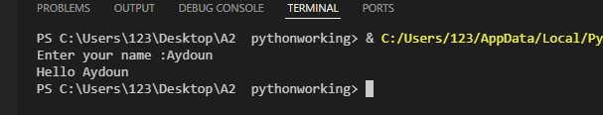

Question 24
Ask the user to enter a number. Print the number multiplied by 2.
Code
# Declare num, number: Integer
num = float (input("Enter the number :"))
number = num *2
print(number)

Terminal
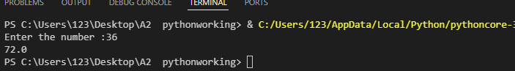

Question 25
Ask the user to enter two numbers. Print their sum.
Code
# Declare num1,num2, number: float
num1 = float (input("Enter the number :"))
num2 = float (input("Enter the second number :"))
number = num1 + num2
print(number)

Terminal
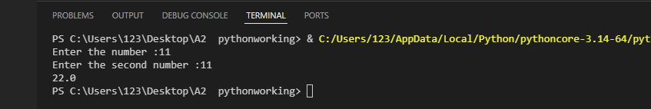

Question 26
Ask the user to enter the length and width of a rectangle. Calculate and print the area.
Code
# Declare length,width, square: Float
length = float (input("Enter the length :"))
width = float (input("Enter the second width :"))
square = length * width
print(square)

Terminal
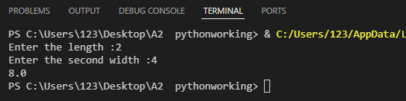

Question 27
Ask the user to enter their age. Print a message saying "In 10 years, you will be" followed by their age plus 10.
Code
# Declare age,future: Float
age = float(input("Enter your age :"))
future = age + 10
print ("In 10 years you would be", future)

Terminal
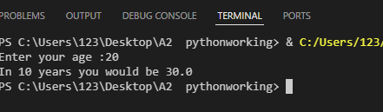

Question 28
Ask the user to enter a temperature in Celsius. Convert it to Fahrenheit using the formula (C × 9/5) + 32 and print the result.
Code
# Declare Cel , Fahrenheit: Float
Cel = float(input("Enter the temperature:"))
Fahrenheit = (Cel * 9/5) + 32
print (Fahrenheit)

Terminal
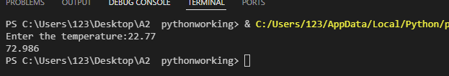

Selection Statements - Basic (Q29-35)
Question 29
Ask the user to enter a number. If the number is greater than 100, print "Large number".
Code
#Declare num : Float
num = float(input("enter the number:"))
if num > 100:
print("large number")

Terminal
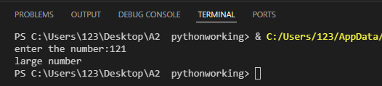

Question 30
Ask the user to enter their age. If the age is 18 or above, print "You are an adult". Otherwise, print "You are a minor".
Code
#Declare age : Float
age = float(input("enter your age :"))
if age >= 18:
print("You are an adult ")
else:
print("You are a minor")

Terminal
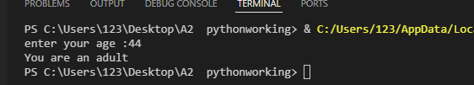

Question 31
Ask the user to enter a number. If it's positive, print "Positive". If it's negative, print "Negative". If it's zero, print "Zero".
Code
#Declare num : Float
num = float (input("Enter the number : "))
if num > 0:
print ('positive')
elif num < 0 :
print("Negative ")
else:
print ("Zero")

Terminal
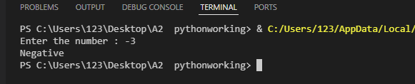

Question 32
Ask the user to enter a password. If the password is "secret123", print "Access granted". Otherwise, print "Access denied".
Code
#Declare password: String
password = (input("Enter the number : "))
if password == "secret123":
print("Access granted")
else :
print("Access denied ")

Terminal
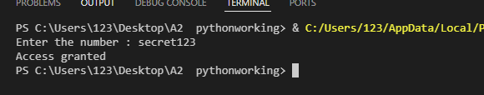

Question 33
Ask the user to enter two numbers. Print which one is larger, or if they are equal.
Code
#Declare num1 , num2 : Integer
num1 = float (input("Enter the number : "))
num2 = float (input("Enter the number : "))
if num1 > num2:
print("Num1 is the largest")
else:
print("Num2 is the largest")

Terminal
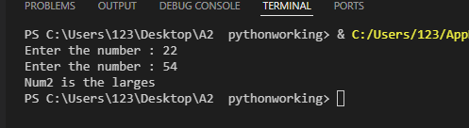

Question 34
Ask the user to enter a number. If it's even (divisible by 2 with no remainder), print "Even". Otherwise, print "Odd". Hint: Use the modulus operator % (Research Div And Mod)
Code
#Declare num : Real
num = float (input("Enter the number : "))
if num % 2 == 0 :
print("Its even")
else:
print ("its odd ")

Terminal
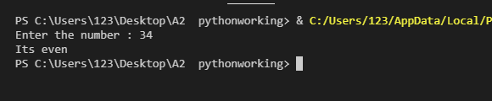

Question 35
Ask the user to enter a grade (A, B, C, D, or F). Print the corresponding message:
- A: "Excellent"
- B: "Good"
- C: "Average"
- D: "Below Average"
- F: "Fail"
Code
#Declare grade : String
grade= (input("Enter the grade : "))
if grade == "A":
print = "Excellent"
elif grade == "B":
print("Good")
elif grade == "C":
print("Average")
elif grade == "D":
print ("Below Average")
elif grade == "F" :
print("Fail")

Terminal
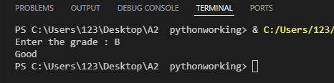

MEDIUM LEVEL (Questions 36-70)
Loops - For Loop Basics (Q36-42)
Question 36
Write a program that prints numbers from 0 to 9 using a for loop.
Code
for x in range (10):
print(x)

Terminal
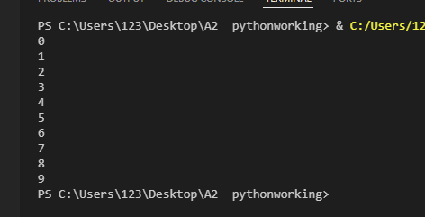

Question 37
Write a program that prints numbers from 1 to 20 using a for loop.
Code
for x in range (1 , 21):
print(x)

Terminal
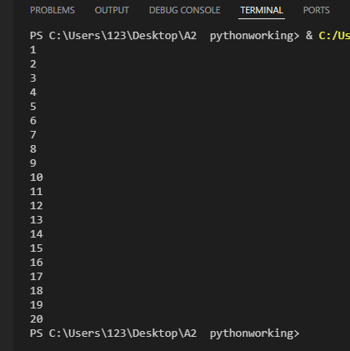

Question 38
Print "Hello" 5 times using a for loop.
Code
for x in range (5):
print("hello")

Terminal
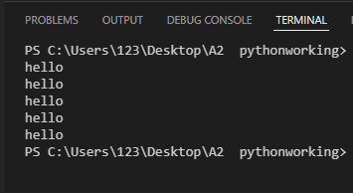

Question 39
Ask the user to enter their name. Print their name 10 times using a for loop.
Code
#Declare name : String
name = input("enter your name:")
for x in range (10):
print (x,name)

Terminal
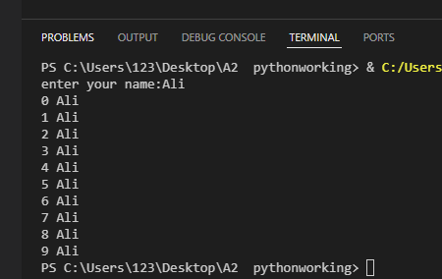

Question 40
Write a program that prints the first 10 multiples of 5 (5, 10, 15, ... 50).
Code
#Declare num : Integer
num = 5
for x in range (10):
num = num + 5
print (num)

Terminal
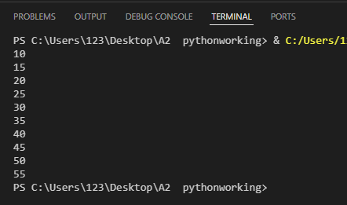

Question 41
Print all even numbers from 2 to 20 using a for loop.
Code
for x in range (2 , 21, 2):
print(x)

Terminal
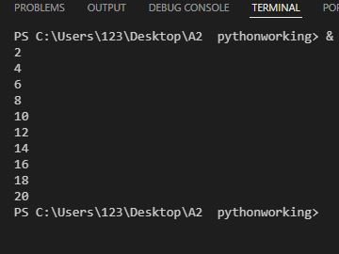

Question 42
Ask the user to enter a number. Print the multiplication table of that number (from 1 to 10) in proper format use string concatenation
Code
#Declare num,table : Integer
num = int(input ("enter the number:"))
for x in range (10):
table = num * x
print(str(num)+ " " + "X" +" "+ str(x) + "=" + str (table))

Terminal
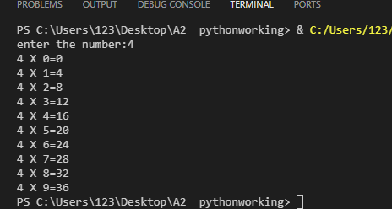

Loop Techniques - Sum, Count, Largest, Smallest (Q43-52)
Question 43
Ask the user to enter 5 numbers. Calculate and print their sum.
Code
#Declare sum,num: Integer
sum = 0
for x in range (5):
num = int(input ("enter the number:"))
sum = sum + num
print(sum)

Terminal
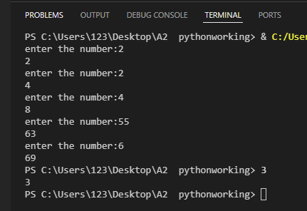

Question 44
Ask the user to enter 10 numbers. Calculate and print their average.
Code
#Declare sum, count , average ,num: Integer
sum = 0
count = 0
for x in range (10):
num = int(input ("enter the number:"))
sum = sum + num
count = count + 1

average = sum / count
print(int(average))

Terminal
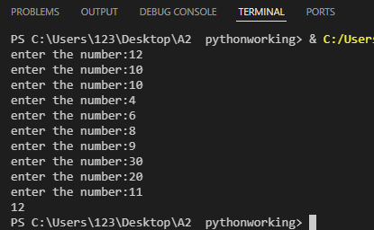

Question 45
Ask the user to enter 5 numbers. Print how many of them are positive.
Code
#Declare poscount : Integer
poscount = 0
for x in range (5):
num = int(input ("enter the number:"))
if num > 0 :
print ("Psoitve")
poscount = poscount +1
print("the positive are :" + str(poscount))

Terminal
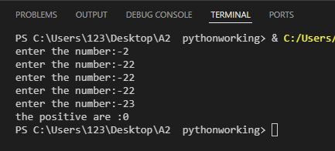

Question 46
Ask the user to enter 8 numbers. Count and print how many are greater than 50.
Code
#Declare count , num : Integer
count = 0
for x in range (8):
num = int(input ("enter the number:"))
if num > 50 :
count = count +1
print("the number greater than 50 :" + " "+ str(count))

Terminal
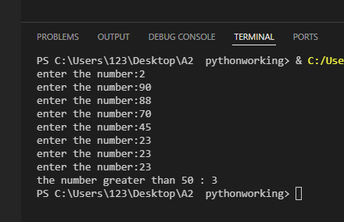

Question 47
Ask the user to enter 5 numbers. Find and print the largest number. Hint: Use the first number as reference.
Code
#Declare num : Integer
# Declare largest : Real
largest = float(input ("enter the number 1 :"))
for x in range (5):
num = int(input ("enter the number:"))
if num > largest :
largest = num

print ("the largest number is :" + " " + str(largest))
Terminal
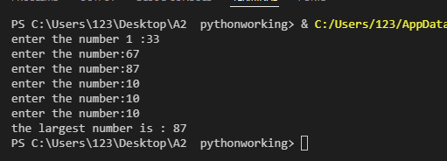

Question 48
Ask the user to enter 5 numbers. Find and print the smallest number. Hint: Use the first number as reference.
Code
#Declare num : Integer
# Declare smallest : Real
smallest = float(input ("enter the number 1 :"))
for x in range (5):
num = int(input ("enter the number:"))
if num < smallest :
smallest = num

print ("the smallest number is :" + " " + str(smallest))

Terminal
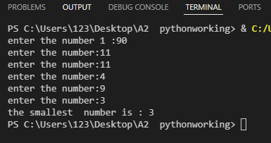

Question 49
Ask the user to enter 10 numbers. Count how many are even and how many are odd. (Research)
Code
# Declare Evencount , oddcount , num : Integer
Evencount = 0
oddcount = 0
for x in range (10):
num = int(input ("enter the number:"))
if num % 2 == 0:
Evencount = Evencount + 1
else :
oddcount = oddcount +1

print('Evencount is = '+ str(Evencount))
print('oddcount is =' + str(oddcount))
Terminal
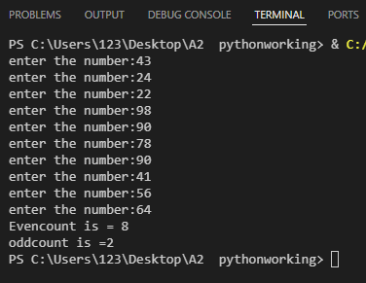

Question 50
Ask the user to enter 6 numbers. Find both the largest and smallest numbers and print them.
Code
#Declare number, largest ,smallest ,num: Real
number = float(input("Enter the number:"))
largest = number
smallest = number
for x in range(5):
num = float(input("Enter the num" + str(x) + ":"))
if largest < num:
largest = num
elif smallest > num:
smallest = num
print ("The largest num is "+ str(largest))
print ("The smallest number is:"+ str(smallest))

Terminal
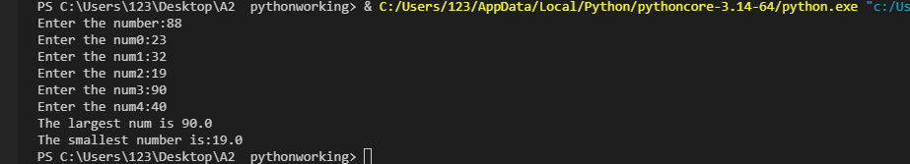

Question 51
Ask the user to enter numbers until they enter 0. Print the sum of all the numbers entered (excluding the 0).
Code
#Declare flag :Boolean
# Declare sum ,index , num : Integer
sum = 0
index = 1
flag = False
while flag == False :
num = float (input("enter the num:"))
if num == 0 :
flag = True
else:
sum = sum + num
index = index + 1
print (sum)

Terminal
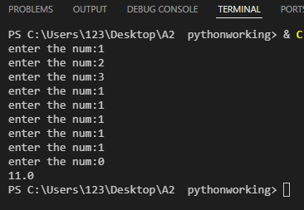

Question 52
Ask the user to enter numbers until they enter -1. Print the count of numbers entered and their average (excluding the -1).
Code
#Declare flag : Boolean
# Declare sum ,index , num,count , avg : Integer
sum = 0
count = 0
index = 1
flag = False
while flag == False :
num = float (input("enter the num:"))
if num == -1 :
flag = True
else:
sum = sum + num
count = count + 1
avg = sum /count
index = index + 1
print (avg)

Terminal
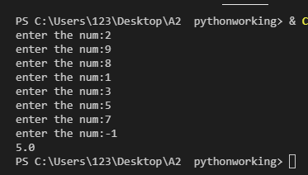

While Loops (Q53-57)
Question 53
Use a while loop to print numbers from 1 to 10.
Code
#Declare i : Integer
i = 1
while i <= 10 :
print (i)
i = i + 1

Terminal
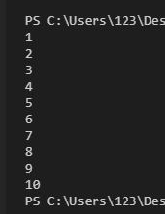

Question 54
Ask the user to enter a password. Keep asking until they enter the correct password "python123".
Code
#Declare flag : Boolean
flag = False
while flag == False :
password = input("Enter the password :")
if password == "python123":
flag = True
else :
print("enter again")

Terminal
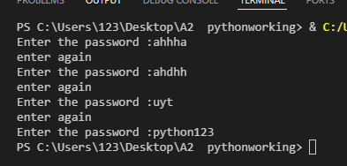

Question 55
Use a while loop to calculate the sum of numbers from 1 to 100.
Code
#Declare i ,sum : Integer
i = 0
sum = 0
while i <= 100 :
sum = sum + i
i = i + 1
print (sum)

Terminal
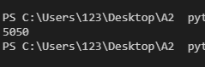

Question 56
Ask the user to guess a secret number (42). Keep asking until they guess correctly. Print how many attempts it took.
Code
#Declare flag : Boolean
#Declare num ,count : Integer
count = 0
flag = False
while flag == False :
num = float(input("Enter num :"))
if num == 42 :
flag = True
else :
print("Do again")
count = count + 1
print("The number of attempts are :" + str(count))
Terminal
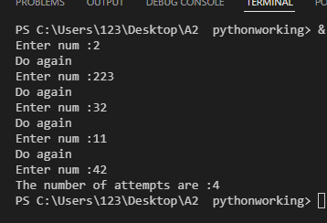

Question 57
Ask the user to enter positive numbers. Stop when they enter a negative number. Print the sum of all positive numbers entered.
Code
#Declare flag : Boolean
#Declare sum ,num : Integer
sum = 0
flag = False
while flag == False :
num = float(input("Enter positive number :"))
if num < 0 :
flag = True
else :
sum = sum + num
print (sum)
Terminal
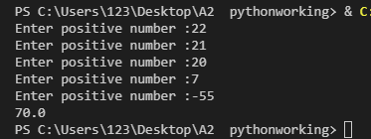

String Manipulation (Q58-62)
Question 58
Create a variable text = "Programming". Print the first 4 characters.
Code
#Declare sen : String
sen = "Programming"
print(sen[0:4])
Terminal
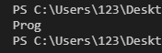
Question 59
Create a variable fullName = "John Smith". Separate and print the first name and last name.
Code
#Declare fullname , firstname , lastname: String
fullname = "John Smith"
firstname = fullname[0:4]
lastname = fullname[5:len(fullname)]
print(firstname)
print(lastname)
Terminal
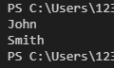

Question 60
Ask the user to enter a word. Print the length of the word.
Code
#Declare word: String
word = input("enter the word:")
print (len(word))

Terminal
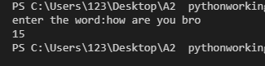

Question 61
Ask the user to enter their full name (first and last name separated by space). Print only their last name.
Code
#Declare flag : Boolean
#Declare name ,lastname: String
#Declare firstnamelen, i : Integer
name = input("Enter the name :")
firstnamelen = 0
i = 0
flag = False
while flag == False:
if name[i] == " ":
flag = True
else:
firstnamelen = firstnamelen + 1
i = i + 1
lastname = name[firstnamelen+1 : len(name)]
print (lastname)

Terminal
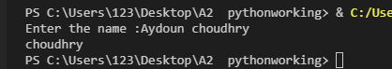

Question 62
Create a variable email = "student@school.com". Extract and print only the part before the @ symbol.
Code
#Declare flag : Boolean
#Declare student, school ,email, studentname: String
#Declare mail, i : Integer
student = input("Enter the studentname :")
school = input("Your schoolname:")
email = (student + "@" +school )
mail = 0
i = 0
flag = False
while flag == False:
if email[i] == "@":
flag = True
else:
mail = mail + 1
i = i + 1
studentname = email[0 : mail]
print (studentname)
Terminal
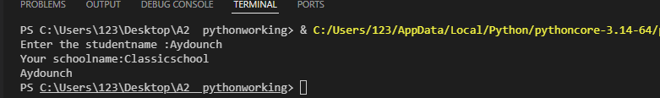

1D Arrays - Basics (Q63-70)
Question 63
Create an array called fruits with 5 fruit names. Print all the fruits using a for loop.
Code
#Declare furits : String
fruits = ["apple" , "mango" ,"grape" , "peach" , "apricot"]
for x in range (5):
print (fruits[x])
Terminal
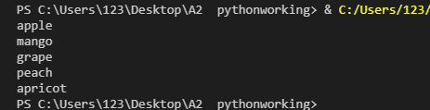
Question 64
Create an array of 5 numbers. Print the sum of all numbers in the array.
Code
#Declare number, sum : Integer
number = [10 , 15 ,20 ,10, 5]
sum = 0
for x in range (5):
sum = sum + number[x]
print (sum)
Terminal
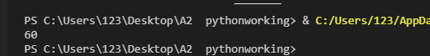

Question 65
Create an array scores = [85, 90, 78, 92, 88]. Find and print the highest score.
Code
#Declare scores : Array [0:4] of Integer
#Declare highest : Integer
scores= [85, 90 , 78 , 92, 88]
highest = scores[0]
for x in range (len(scores)):
if scores[x] > highest :
highest = scores[x]
print ("the highest is :" ,highest)
Terminal

Question 66
Create an array of 6 numbers. Print the average of all numbers.
Code
#Declare sixnum ,sum, count :Integer
#Declare avg : Real
sixnum = [5, 9, 8, 10, 12, 2]
sum = 0
count = 0
for x in range (6):
sum = sum + sixnum[x]
count = count +1
avg = sum / count
print(avg)
Terminal
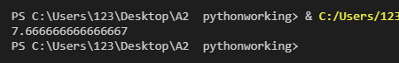

Question 67
Create an array names = ["Ali", "Sara", "Omar", "Hiba", "Zain"]. Ask the user to enter a name. Print whether the name is in the array or not.
Code
#Declare flag : Boolean
#Declare names : Array [0:4] of String
names = ["Ali", "Sara", "Omar", "Hiba", "Zain"]
name = input("Enter a name:")
flag = False
for x in range (len(names)):
if name == names[x]:
flag = True
if flag == True :
print(name +" "+ "it is in the array")
else:
print(name + " "+ "name is not in array ")
Terminal
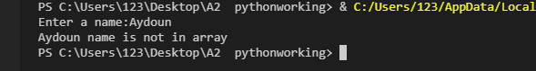

Question 68
Create an array of 5 numbers. Count and print how many numbers are greater than the average.
Code
#Declare num : Array [0:4] of Integer
#Declare count,greater ,sum,avg : Integer
num= [10, 25, 30, 15, 20]
count = 0
greater = 0
sum = 0
for x in range (len(num)):
count = count + 1
sum = sum + num[x]
avg = sum / count
if num[x] > avg :
greater = greater + 1
print (greater)
print (avg)
Terminal
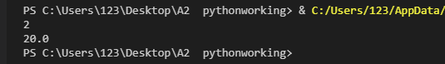
Question 69
Create an empty array. Ask the user to enter 5 names and add each name to the array using append(). Print all names.
Code
#Declare Names: Array [0:4] of String
#Declare name: String
Names = []
for x in range (5):
name = input ("Enter the name:")
Names.append(name)
print(Names)
Terminal
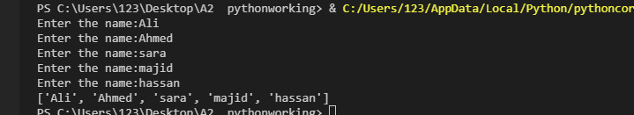

Question 70
Create an array numbers = [10, 25, 30, 15, 20]. Print the numbers in reverse order.
Code
#Declare numbers ,newnum: Array [0:4] of Integer
#Declare oppositeindex: Integer
numbers = [10, 25, 30, 15, 20]
newnum = [0,0,0,0,0]
oppositeindex = 4
for x in range(len(numbers)):
newnum[x] = numbers[oppositeindex]
oppositeindex = oppositeindex - 1

print(newnum)

Terminal
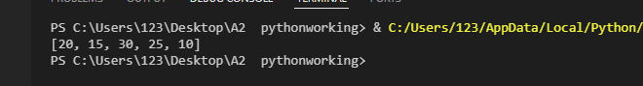
HARD LEVEL (Questions 71-100)
Advanced Array Operations (Q71-78)
Question 71
Create an array of 10 numbers. Find the second largest number in the array.
Code
#Declare numbers : Array [0:9] of Integer
#Declare largest , seclargest: Integer
numbers = [10, 25, 30, 15, 20, 35 , 19, 76 , 90, 31]
largest = numbers[0]
seclargest = numbers[0]
for x in range(1 ,len(numbers)):
if largest < numbers[x]:
largest = numbers[x]
for x in range(len(numbers)):
if seclargest < numbers[x] and numbers[x] != largest:
seclargest = numbers[x]
print(seclargest)
print (largest)
Terminal
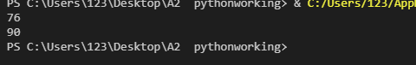

Question 72
Create an array of names. Ask the user to enter a name. If found, print its index position. If not found, add it to the array.
Code
#Declare Names: Array [0:4] of String
#Declare name : String
# Declare count : Integer
Names = ["Ali", "Sara", "Omar", "Hiba", "Zain"]
name = input("Enter a name: ")
count = 0
for x in range (len(Names)):
if Names[x] == name:
count = count + 1
print (Names[count])
if Names[x] != name:
Names.append(name)
print(Names)
Terminal
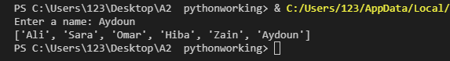
Question 73
Create two arrays of 5 numbers each. Create a third array that contains the sum of corresponding elements from both arrays.
Code
#Declare number1 ,number2 , number3 : Array [0:4] of Integer
number1 = [10, 25, 30, 15, 20]
number2 = [ 2, 4 , 6, 8, 10]
number3 = [ 0 ,0 ,0 ,0 ,0 ]
for x in range (len(number1)):
number3[x] = number1[x] + number2[x]
print (number3)
Terminal
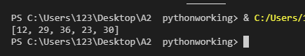

Question 74
Create an array of 8 numbers. Separate positive numbers into one array and negative numbers into another array. Print both arrays.
Code
#Declare number ,negnumber , posnumber : Array [0:4] of Integer
number = [10, 25, 30, 15, 20 , -33 , -21 , -22]
posnumber = []
negnumber = []
for x in range (8):
if number[x] < 0:
negnumber.append(number[x])
else :
posnumber.append(number[x])
print(negnumber)
print(posnumber)
Terminal
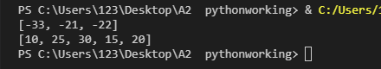
Question 75
Create an array of 10 numbers. Remove all duplicate values and print the array with unique values only.
Code
#Declare flag : Boolean
#Declare Number : Array [0:8] of Integer
#Declare uniqueval :Array of Integer
Number = [25, 30, 15, 20 , 25 , 8 ,22 , 30, 99 ]
uniqueval=[]
for x in range (len(Number)):
flag = False
for y in range(len (uniqueval)):
if Number[x] == uniqueval[y]:
flag = True
if flag == False:
uniqueval.append(Number[x])
print(Number)
print(uniqueval)
Terminal
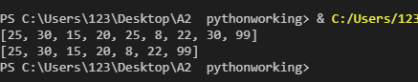

Question 76
Create an array of 6 numbers. Shift all elements one position to the right (last element becomes first).
Code
#Declare numbers : ARRAY[0:5] OF INTEGER
#Declare lastElement : INTEGER
#Declare shiftedArray : ARRAY[0:5] OF INTEGER
numbers = [10, 20, 30, 40, 50, 60]
print(numbers)
lastElement = numbers[len(numbers) - 1]
shiftedArray = [0] * len(numbers)
shiftedArray[0] = lastElement
for x in range(len(numbers) - 1):
shiftedArray[x + 1] = numbers[x]
print("After shifting right:", shiftedArray)
Terminal
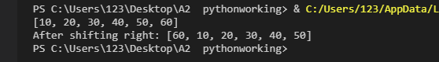

Question 77
Create an array of words. Sort them alphabetically using the bubble sort technique. (You can try to solve this code but not compulsory for now.)
Code
{Copy and paste program code here}

Terminal
{Take the screenshot of the output and past the screenshot here}

Question 78
Number = [ 12, 14, 15, 16, 43, 25, 15, 65, 72, 12]
Create an array of 10 numbers. Find and print all numbers that appear more than once.
Code
# Declare numbers : ARRAY[0:9] OF INTEGER
# Declare duplicates : ARRAY OF INTEGER
# Declare count : INTEGER
# Declare alreadyAdded : BOOLEAN
numbers = [12, 14, 15, 16, 43, 25, 15, 65, 72, 12]
duplicates = []
for x in range(len(numbers)):
count = 0
for y in range(len(numbers)):
if numbers[x] == numbers[y]:
count = count + 1
if count > 1:
alreadyAdded = False
for z in range(len(duplicates)):
if duplicates[z] == numbers[x]:
alreadyAdded = True
if alreadyAdded == False:
duplicates.append(numbers[x])
print(numbers)
print("Numbers appearing more than once:", duplicates)
Terminal
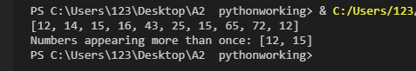

2D Arrays (Q79-85)
Question 79
Create a 3x3 (Row and Col) 2D array and initialize all elements with 0. Print the array in matrix format(only the rows).
Code
#Declare array2D : Array [0:3][0:3] OF Integer
array2D =[[0]*3 for i in range(3)]
for row in range(3):
print(array2D[row])

Terminal
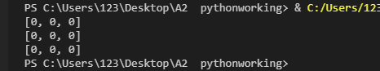

Question 80
Create a 4x4 2D array. Fill it with numbers 1 to 16 (row by row). Print the array.
Code
# Declare array2D : ARRAY[0:3, 0:3] OF INTEGER
# Declare counter : INTEGER
array2D = [[0] * 4 for x in range(4)]
counter = 1
for row in range(4):
for col in range(4):
array2D[row][col] = counter
counter = counter + 1
for row in range(4):
print(array2D[row])

Terminal
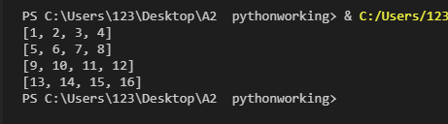
Question 81
Create a 3x3 2D array and take 9 numbers from the user, store it in the array then Calculate and print the sum of all elements.
Code
#Declare array2D : Array [0:3 , 0:3] as Integer
#Declare sum : Intger
#Declare num : Real
array2D = [[0]*3 for i in range(3)]
sum = 0
for row in range(3):
for col in range(3):
num = float(input ("Enter the number:"))
array2D[row][col] = num
sum = sum + num
print(array2D)
print(sum)
Terminal
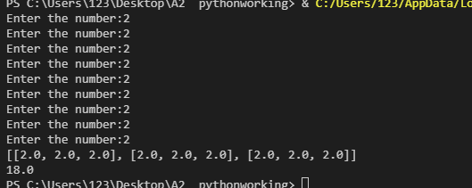

Question 82
Create a 4x5 2D array with student marks (4 students, 5 subjects each). Calculate and print the average marks for each student.
Code
# Declare marks : ARRAY[0:3, 0:4] OF INTEGER
# Declare total : INTEGER
# Declare average : REAL
marks = [
[85, 90, 78, 92, 88],
[76, 82, 79, 85, 80],
[90, 95, 88, 92, 94],
[70, 75, 72, 68, 78]
]
for row in range(4):
print("Student " + str(row + 1) + ":", marks[row])
print("Average marks for each student:")
for row in range(4):
total = 0
for col in range(5):
total = total + marks[row][col]
average = total / 5
print("Student " + str(row + 1) + " average:", average)
Terminal
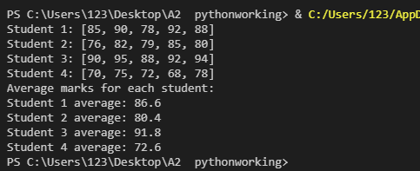
Question 83
Create a 3x3 2D array. Find and print the largest element and its position (row, column).
Code
# Declare array2D : ARRAY[0:2, 0:2] OF INTEGER
# Declare largest : INTEGER
# Declare largestRow : INTEGER
# Declare largestCol : INTEGER
array2D = [
[45, 23, 89],
[12, 67, 34],
[78, 56, 90]
]
largest = array2D[0][0]
largestRow = 0
largestCol = 0
for row in range(3):
for col in range(3):
if array2D[row][col] > largest:
largest = array2D[row][col]
largestRow = row
largestCol = col
print(largest)
print("Position: Row", largestRow, ", Column", largestCol)
Terminal
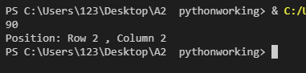

Question 84
Create a 5x5 2D array. Calculate the sum of elements in the main diagonal (where row index equals column index).
Code
# Declare array2D : ARRAY[0:4, 0:4] OF INTEGER
# Declare diagonalSum : INTEGER
array2D = [
[1, 2, 3, 4, 5],
[6, 7, 8, 9, 10],
[11, 12, 13, 14, 15],
[16, 17, 18, 19, 20],
[21, 22, 23, 24, 25]
]
print("The 5x5 array:")
for row in range(5):
print(array2D[row])
diagonalSum = 0
for x in range(5):
diagonalSum = diagonalSum + array2D[x][x]
print("Sum of main diagonal elements:", diagonalSum)
print("(Elements: 1 + 7 + 13 + 19 + 25 = 65)")

Terminal
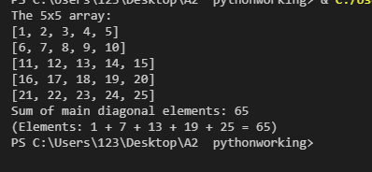

Question 85
Create a 3x4 2D array. Calculate and print the sum of each column.
Code
# Declare array2D : ARRAY[0:2, 0:3] OF INTEGER
# Declare colSum : INTEGER
array2D = [
[10, 20, 30, 40],
[15, 25, 35, 45],
[12, 22, 32, 42]
]
print("Sum of each column:")
for col in range(4):
colSum = 0
for row in range(3):
colSum = colSum + array2D[row][col]
print("Column " + str(col) + " sum:", colSum)
Terminal
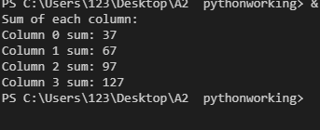
Functions (Q86-92)
Question 86
Create a function called greet that takes a name as parameter and prints "Hello, " followed by the name. Make sure to use a sample value and output the result.
Code
#Declare greet: String
def greet(name):
print("Hello " + name)

greet("Aydoun")
Terminal
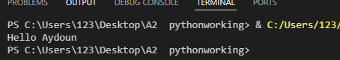

Question 87
Create a function called calculateArea that takes length and width as parameters and returns the area of a rectangle. Make sure to use a sample value and output the result.
Code
#Declare area , cal : Integer
def area(len , width):
cal = len * width
return cal
print(area(2 , 4))

Terminal
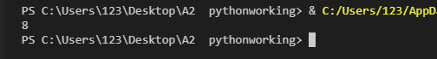
Question 88
Create a function called isEven that takes a number as parameter and returns True if even, False if odd. Make sure to use a sample value and output the result.
Code
#Declare even: Integer
def iseven(num):
even = num % 2
if even == 0:
return True
else:
return False
print(iseven(6))
Terminal
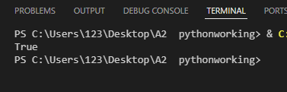

Question 89
Create a function called findMax that takes three numbers as parameters and returns the largest one. For testing make sure to input three numbers 32, 1, 43 and then output result with suitable message.
Code
#Declare Findmax: Integer
def findmax(num1,num2,num3):
if num1 > num2 and num1 > num3 :
return num1
elif num2 > num1 and num2 > num3 :
return num2
else :
return num3
print(findmax(32 , 1, 43))
Terminal
Question 90
Create a function called factorial that takes a number and returns its factorial. Make sure to use a sample value and output the result.
Code
def fac(n):
if n <= 1 :
return n
result = 1
for x in range(1 , n + 1):
result = result * x
return result
print(fac(5))

Terminal
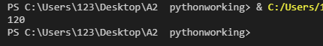

Question 91
Create a function called isPrime that takes a number and returns True if it's a prime number, False otherwise. Make sure to use a sample value and output the result.
Code
def isprime(n):
if n <= 1 :
return False
for x in range(2 , n):
if n % x == 0:
return False
return True
print(isprime(2))
Terminal
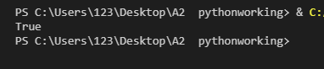

Question 92
Create a function called countVowels that takes a string and returns the count of vowels in it. Make sure to use a sample value and output the result.
Code
def countVowels(str):
count = 0
vowels = "aeiouAEIOU"
for x in range(len(str)):
for y in range(len(vowels)):
if str[x] == vowels[y]:
count = count +1
return count
print(countVowels("hi how are and what are you doing"))
Terminal
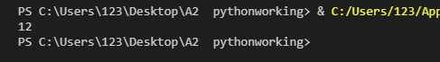

Functions with Arrays (Q93-97)
Question 93
Create a function called arraySum that takes an array as parameter and returns the sum of all elements.
Code
def arraysum(array):
sum= 0
for x in range(len(array)):
sum = sum + array[x]
return sum
print(arraysum([10 , 20, 21, 30 , 40 ]))
Terminal
Question 94
Create a function called findLargest that takes an array as parameter and returns the largest element.
Code
def findlargest(array):
largest = array[0]
for x in range(len(array)):
if largest < array[x]:
largest = array [x]
return largest
print(findlargest([10 , 20, 21, 30 , 40 ]))
Terminal
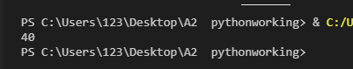

Question 95
Create a function called linearSearch that takes an array and a search value as parameters. Return the index if found, -1 if not found.
Code
def linearsearch(array , val):
for x in range(len(array)):
if val == array[x]:
return x
return -1
print (linearsearch([10 , 20, 21, 30 , 29] ,21))
Terminal
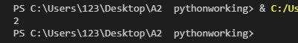
Question 96
Create a function called countOccurrences that takes an array and a value as parameters. Return how many times the value appears in the array.
Code
def countOccurences(array , val):
count = 0
for x in range(len(array)):
if array[x] == val:
count = count + 1
return count
print(countOccurences([10 , 20 , 10 , 30 ,30 , 81, 90] , 10) )
Terminal
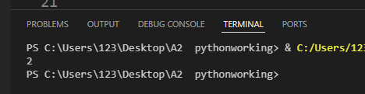

Question 97
Create a function called reverseArray that takes an array as parameter and returns a new array with elements in reverse order.
Code
def reverseArray(arr):
reversedArr = []
for x in range(len(arr) - 1, -1, -1):
reversedArr.append(arr[x])
return reversedArr
result = reverseArray([10, 20, 30, 40, 50])
print(result)

Terminal
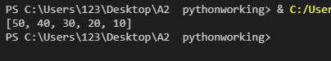

Combined Concepts (Q98-100)
Question 98
Student Grade System Create a program that:
- Asks for the number of students
- For each student, asks for 5 subject marks
- Stores all marks in a 2D array
- Creates a function to calculate average
- Creates a function to assign grade based on average:
  - 90+: A
  - 80-89: B
  - 70-79: C
  - 60-69: D
  - Below 60: F
- Prints each student's average and grade
Code
def calculateAverage(marks):
total = 0
for x in range(len(marks)):
total = total + marks[x]
average = total / len(marks)
return average

def assignGrade(average):
if average >= 90:
return "A"
elif average >= 80:
return "B"
elif average >= 70:
return "C"
elif average >= 60:
return "D"
else:
return "F"
numStudents = int(input("Enter the number of students: "))
studentMarks = []
for student in range(numStudents):
print("Enter marks for Student " + str(student + 1) + ":")
marks = []
for subject in range(5):
mark = float(input(" Subject " + str(subject + 1) + ": "))
marks.append(mark)
studentMarks.append(marks)
print("\n--- Student Results ---")
for student in range(numStudents):
avg = calculateAverage(studentMarks[student])
grade = assignGrade(avg)
print("Student " + str(student + 1) + ": Average = " + str(avg) + ", Grade = " + grade)

Terminal
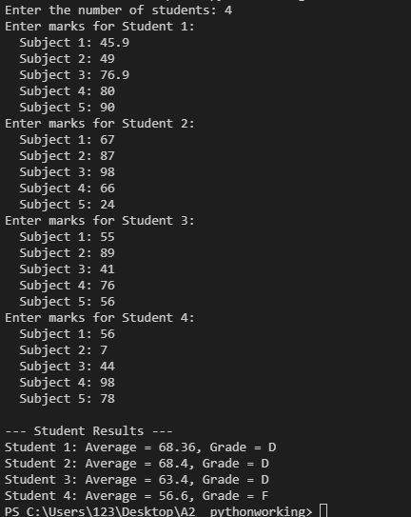

Question 99
Number Analysis Program Create a program that:
- Asks the user to enter numbers until they enter -999
- Stores all numbers in an array
- Creates functions for:
  - Finding the sum
  - Finding the average
  - Finding the largest
  - Finding the smallest
  - Counting positive and negative numbers
- Prints all analysis results
Code
def findSum(arr):
total = 0
for x in range(len(arr)):
total = total + arr[x]
return total

def findAverage(arr):
if len(arr) == 0:
return 0
return findSum(arr) / len(arr)

def findLargestNum(arr):
largest = arr[0]
for x in range(1, len(arr)):
if arr[x] > largest:
largest = arr[x]
return largest

def findSmallestNum(arr):
smallest = arr[0]
for x in range(1, len(arr)):
if arr[x] < smallest:
smallest = arr[x]
return smallest

def countPositiveNegative(arr):
positive = 0
negative = 0
for x in range(len(arr)):
if arr[x] > 0:
positive = positive + 1
elif arr[x] < 0:
negative = negative + 1
return positive, negative
numbers = []
number = float(input("Enter a number (-999 to stop): "))
while number != -999:
numbers.append(number)
number = float(input("Enter a number (-999 to stop): "))
if len(numbers) > 0:
print("--- Number Analysis ---")
print("Numbers entered:", numbers)
print("Sum:", findSum(numbers))
print("Average:", findAverage(numbers))
print("Largest:", findLargestNum(numbers))
print("Smallest:", findSmallestNum(numbers))
positiveCount, negativeCount = countPositiveNegative(numbers)
print("Positive numbers:", positiveCount)
print("Negative numbers:", negativeCount)

Terminal
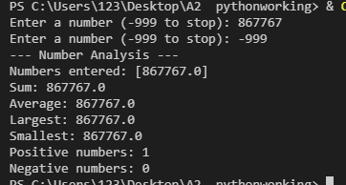
Question 100
Ask the user to enter the number of rows. Print the following centered pyramid pattern (Pattern if rows input 5)
*
***
*****
*******
*********
Code
# Declare numRows : INTEGER
# Declare spaces : STRING
# Declare stars : STRING

numRows = int(input("Enter the number of rows: "))
for row in range(1, numRows + 1):
# Build the spaces
spaces = ""
for x in range(numRows - row):
spaces = spaces + " "

# Build the stars
stars = ""
for y in range(2 * row - 1):
stars = stars + "*"

# Combine and print
line = spaces + stars
print(line)

Terminal
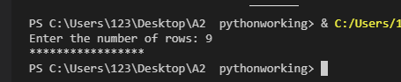

Answers
Print, Variables & Data Types (Q1-10)
Easy Level Question
Question 1
Write a program that prints "Hello, World!" on the screen.
print("Hello, World!")
# Expected Output:
# Hello, World!
Question 2
Create a variable called age and assign the value 17 to it. Print the value of age.
# Declare age : INTEGER
age = 17
print(age)
# Expected Output: 17
Question 3
Declare two variables: firstName with value "Ahmed" and lastName with value "Khan". Print both variables.
# Declare firstName : STRING
# Declare lastName : STRING
firstName = "Ahmed"
lastName = "Khan"
print(firstName)
print(lastName)
# Expected Output:
# Ahmed
# Khan

Question 4
Create a variable price with value 99.99. Use the type() function to print the datatype.
# Declare price : REAL
price = 99.99
print(type(price))
# Expected Output: <class 'float'>
Question 5
Create a variable number with value 45.78. Convert it to an integer and print the result.
# Declare number : REAL
# Declare numberInteger : INTEGER
number = 45.78
numberInteger = int(number)
print(numberInteger)
# Expected Output: 45
Question 6
Assign the value "123" (as a string) to a variable called numString. Convert it to an integer, add 10 to it, and print the result.
# Declare numString : STRING
# Declare result : INTEGER
numString = "123"
result = int(numString) + 10
print(result)
# Expected Output: 133

Question 7
Create three variables: a = 10, b = 20.5, c = "Hello". Print the datatype of each variable.
a = 10
b = 20.5
c = "Hello"
print(type(a))
print(type(b))
print(type(c))
# Expected Output:
# <class 'int'>
# <class 'float'>
# <class 'str'>
Question 8
Write a program that stores your school name in a variable and prints it with a welcome message.
# Declare schoolName : STRING
schoolName = "City Grammar School"
print("Welcome to " + schoolName)
# Expected Output: Welcome to City Grammar School
Question 9
Create a variable temperature with value 36.6. Print a message saying "The temperature is: " followed by the value.
# Declare temperature : REAL
temperature = 36.6
print("The temperature is:", temperature)
# Expected Output: The temperature is: 36.6

Question 10
Declare a variable year with value 2026. Print a message that says "Paper 4 exam year is: " followed by the year.
# Declare year : INTEGER
year = 2026
print("Paper 4 exam year is:", year)
# Expected Output: Paper 4 exam year is: 2026

Mathematical Operations (Q11-18)
Question 11
Write a program that calculates and prints the sum of 25 and 75.
# Declare result : INTEGER
result = 25 + 75
print(result)
# Expected Output: 100
Question 12
Create two variables num1 = 100 and num2 = 35. Calculate and print their difference.
num1 = 100
num2 = 35
difference = num1 - num2
print(difference)
# Expected Output: 65
Question 13
Write a program that multiplies 12 by 8 and prints the result.
result = 12 * 8
print(result)
# Expected Output: 96

Question 14
Divide 150 by 4 and print the result.
result = 150 / 4
print(result)
# Expected Output: 37.5
Question 15
Create variables length = 15 and width = 8. Calculate the area of a rectangle and print it.
length = 15
width = 8
area = length * width
print("The area of the rectangle is:", area)
# Expected Output: The area of the rectangle is: 120
Question 16
Write a program that calculates the perimeter of a square with side length 25.
side = 25
perimeter = 4 * side
print("The perimeter of the square is:", perimeter)
# Expected Output: The perimeter of the square is: 100
Question 17
Create a variable radius = 7. Calculate the area of a circle (use 3.14159 for pi) and print the integer part only.
radius = 7
pi = 3.14159
area = pi * radius * radius
print("The area of the circle is:", int(area))
# Expected Output: The area of the circle is: 153

Question 18
Write a program that converts 5 kilometers to meters (multiply by 1000) and prints the result.
kilometers = 5
meters = kilometers * 1000
print(str(kilometers) + " kilometers is equal to " + str(meters) + " meters")
# Expected Output: 5 kilometers is equal to 5000 meters

String Concatenation (Q19-22)
Question 19
Create two variables part1 = "Computer" and part2 = "Science". Concatenate them with a space in between.
part1 = "Computer"
part2 = "Science"
combined = part1 + " " + part2
print(combined)
# Expected Output: Computer Science
Question 20
Store your first name and last name in separate variables. Create a full name by concatenating them with a space.
firstName = "Taha"
lastName = "Ali"
fullName = firstName + " " + lastName
print(fullName)
# Expected Output: Taha Ali

Question 21
Create variables city = "Karachi" and country = "Pakistan". Print them in the format "City: Karachi, Country: Pakistan".
city = "Karachi"
country = "Pakistan"
print("City: " + city + ", Country: " + country)
# Expected Output: City: Karachi, Country: Pakistan
Question 22
Create a variable subject = "Python". Concatenate it with the string " is fun!" and print the result.
subject = "Python"
message = subject + “ ” + "is fun!"
print(message)
# Expected Output: Python is fun!

Input from User (Q23-28)
Question 23
Ask the user to enter their name and print "Hello, " followed by their name.
name = input("Enter your name: ")
print("Hello, " + name)
# Expected Output:
# Enter your name: Ahmed
# Hello, Ahmed

Question 24
Ask the user to enter a number. Print the number multiplied by 2.
number = float(input("Enter a number: "))
result = number * 2
print("The result is:", result)
# Expected Output:
# Enter a number: 15
# The result is: 30.0
Question 25
Ask the user to enter two numbers. Print their sum.
num1 = float(input("Enter first number: "))
num2 = float(input("Enter second number: "))
total = num1 + num2
print("The sum is:", total)
# Expected Output:
# Enter first number: 25
# Enter second number: 30
# The sum is: 55.0
Question 26
Ask the user to enter the length and width of a rectangle. Calculate and print the area.
length = float(input("Enter the length: "))
width = float(input("Enter the width: "))
area = length * width
print("The area of the rectangle is:", area)
# Expected Output:
# Enter the length: 10
# Enter the width: 5
# The area of the rectangle is: 50.0
Question 27
Ask the user to enter their age. Print a message saying "In 10 years, you will be " followed by their age plus 10.
age = int(input("Enter your age: "))
futureAge = age + 10
print("In 10 years, you will be", futureAge)
# Expected Output:
# Enter your age: 16
# In 10 years, you will be 26
Question 28
Ask the user to enter a temperature in Celsius. Convert it to Fahrenheit using the formula (C × 9/5) + 32.
celsius = float(input("Enter temperature in Celsius: "))
fahrenheit = (celsius * 9/5) + 32
print("Temperature in Fahrenheit:", fahrenheit)
# Expected Output:
# Enter temperature in Celsius: 25
# Temperature in Fahrenheit: 77.0

Selection Statements - Basic (Q29-35)
Question 29
Ask the user to enter a number. If the number is greater than 100, print "Large number".
number = float(input("Enter a number: "))
if number > 100:
print("Large number")
# Expected Output:
# Enter a number: 150
# Large number

Question 30
Ask the user to enter their age. If the age is 18 or above, print "You are an adult". Otherwise, print "You are a minor".
age = int(input("Enter your age: "))
if age >= 18:
print("You are an adult")
else:
print("You are a minor")
# Expected Output (Test 1): Enter your age: 20 → You are an adult
# Expected Output (Test 2): Enter your age: 15 → You are a minor
Question 31
Ask the user to enter a number. If it's positive, print "Positive". If it's negative, print "Negative". If it's zero, print "Zero".
number = float(input("Enter a number: "))
if number > 0:
print("Positive")
elif number < 0:
print("Negative")
else:
print("Zero")
# Expected Output: Enter a number: 25 → Positive
Question 32
Ask the user to enter a password. If the password is "secret123", print "Access granted". Otherwise, print "Access denied".
password = input("Enter password: ")
if password == "secret123":
print("Access granted")
else:
print("Access denied")
# Expected Output: Enter password: secret123 → Access granted
Question 33
Ask the user to enter two numbers. Print which one is larger, or if they are equal.
num1 = float(input("Enter first number: "))
num2 = float(input("Enter second number: "))
if num1 > num2:
print(num1, "is larger")
elif num2 > num1:
print(num2, "is larger")
else:
print("Both numbers are equal")
# Expected Output: Enter 50, 30 → 50.0 is larger
Question 34
Ask the user to enter a number. If it's even (divisible by 2 with no remainder), print "Even". Otherwise, print "Odd".
number = int(input("Enter a number: "))
if number % 2 == 0:
print("Even")
else:
print("Odd")
# Expected Output: Enter a number: 24 → Even

Question 35
Ask the user to enter a grade (A, B, C, D, or F). Print the corresponding message.
grade = input("Enter your grade (A, B, C, D, or F): ")
if grade == "A":
print("Excellent")
elif grade == "B":
print("Good")
elif grade == "C":
print("Average")
elif grade == "D":
print("Below Average")
elif grade == "F":
print("Fail")
else:
print("Invalid grade entered")
# Expected Output: Enter grade: A → Excellent

MEDIUM LEVEL (Questions 36-70)
Loops - For Loop Basics (Q36-42)
Question 36
Write a program that prints numbers from 0 to 9 using a for loop.
for x in range(10):
print(x)
# Expected Output: 0, 1, 2, 3, 4, 5, 6, 7, 8, 9 (each on new line)
Question 37
Write a program that prints numbers from 1 to 20 using a for loop.
for x in range(1, 21):
print(x)
# Expected Output: 1, 2, 3, ... 19, 20 (each on new line)
Question 38
Print "Hello" 5 times using a for loop.
for x in range(5):
print("Hello")
# Expected Output: Hello (printed 5 times)
Question 39
Ask the user to enter their name. Print their name 10 times using a for loop.
# Declare name : STRING
name = input("Enter your name: ")
for x in range(10):
print(name)
# Expected Output:
# Enter your name: Ahmed
# Ahmed (printed 10 times)

Question 40
Write a program that prints the first 10 multiples of 5 (5, 10, 15, ... 50).
for x in range(1, 11):
print(x * 5)
# Expected Output: 5, 10, 15, 20, 25, 30, 35, 40, 45, 50
Question 41
Print all even numbers from 2 to 20 using a for loop.
for x in range(2, 21, 2):
print(x)
# Expected Output: 2, 4, 6, 8, 10, 12, 14, 16, 18, 20
Question 42
Ask the user to enter a number. Print the multiplication table of that number (from 1 to 10) in proper format using string concatenation.
# Declare number : INTEGER
number = int(input("Enter a number: "))
for x in range(1, 11):
result = number * x
print(str(number) + " x " + str(x) + " = " + str(result))
# Expected Output (for number = 7):
# 7 x 1 = 7
# 7 x 2 = 14
# 7 x 3 = 21
# ... and so on until 7 x 10 = 70

Loop Techniques - Sum, Count, Largest, Smallest (Q43-52)
Question 43
Ask the user to enter 5 numbers. Calculate and print their sum.
# Declare total : REAL
# Declare number : REAL
total = 0
for x in range(5):
number = float(input("Enter number " + str(x + 1) + ": "))
total = total + number
print("The sum is:", total)
# Expected Output:
# Enter number 1: 10
# Enter number 2: 20
# Enter number 3: 30
# Enter number 4: 40
# Enter number 5: 50
# The sum is: 150.0

Question 44
Ask the user to enter 10 numbers. Calculate and print their average.
# Declare total : REAL
# Declare number : REAL
# Declare average : REAL
total = 0
for x in range(10):
number = float(input("Enter number " + str(x + 1) + ": "))
total = total + number
average = total / 10
print("The average is:", average)
# Expected Output: Enter 10 numbers → prints their average
Question 45
Ask the user to enter 5 numbers. Print how many of them are positive.
# Declare count : INTEGER
# Declare number : REAL
count = 0
for x in range(5):
number = float(input("Enter number " + str(x + 1) + ": "))
if number > 0:
count = count + 1
print("Number of positive numbers:", count)
# Expected Output: Enter 10, -5, 20, -3, 15 → Number of positive numbers: 3

Question 46
Ask the user to enter 8 numbers. Count and print how many are greater than 50.
# Declare count : INTEGER
# Declare number : REAL
count = 0
for x in range(8):
number = float(input("Enter number " + str(x + 1) + ": "))
if number > 50:
count = count + 1
print("Numbers greater than 50:", count)
# Expected Output: Enter 45, 60, 55, 30, 80, 25, 90, 40 → Numbers greater than 50: 4
Question 47
Ask the user to enter 5 numbers. Find and print the largest number. Hint: Use the first number as reference.
# Declare largest : REAL
# Declare number : REAL
largest = float(input("Enter number 1: "))
for x in range(2, 6):
number = float(input("Enter number " + str(x) + ": "))
if number > largest:
largest = number
print("The largest number is:", largest)
# Expected Output: Enter 25, 45, 12, 78, 34 → The largest number is: 78.0

Question 48
Ask the user to enter 5 numbers. Find and print the smallest number. Hint: Use the first number as reference.
# Declare smallest : REAL
# Declare number : REAL
smallest = float(input("Enter number 1: "))
for x in range(2, 6):
number = float(input("Enter number " + str(x) + ": "))
if number < smallest:
smallest = number
print("The smallest number is:", smallest)
# Expected Output: Enter 25, 45, 12, 78, 34 → The smallest number is: 12.0
Question 49
Ask the user to enter 10 numbers. Count how many are even and how many are odd.
# Declare evenCount : INTEGER
# Declare oddCount : INTEGER
# Declare number : INTEGER
evenCount = 0
oddCount = 0
for x in range(10):
number = int(input("Enter number " + str(x + 1) + ": "))
if number % 2 == 0:
evenCount = evenCount + 1
else:
oddCount = oddCount + 1
print("Even numbers:", evenCount)
print("Odd numbers:", oddCount)
# Expected Output: Even numbers: 5, Odd numbers: 5

Question 50
Ask the user to enter 6 numbers. Find both the largest and smallest numbers and print them.
# Declare largest : REAL
# Declare smallest : REAL
# Declare number : REAL
number = float(input("Enter number 1: "))
largest = number
smallest = number
for x in range(2, 7):
number = float(input("Enter number " + str(x) + ": "))
if number > largest:
largest = number
if number < smallest:
smallest = number
print("The largest number is:", largest)
print("The smallest number is:", smallest)
# Expected Output: Enter 45, 23, 89, 12, 67, 34
# The largest number is: 89.0
# The smallest number is: 12.0

Question 51
Ask the user to enter numbers until they enter 0. Print the sum of all numbers (excluding 0).
# Declare total : REAL
# Declare number : REAL
# Declare flag : BOOLEAN

total = 0
flag = False
while flag == False:
number = float(input("Enter a number (0 to stop): "))
if number == 0:
flag = True
else:
total = total + number
print("The sum is:", total)
# Expected Output:
# Enter a number (0 to stop): 10
# Enter a number (0 to stop): 20
# Enter a number (0 to stop): 30
# Enter a number (0 to stop): 0
# The sum is: 60.0

Question 52
Ask the user to enter numbers until they enter -1. Print the count and their average (excluding -1).
# Declare total : REAL
# Declare count : INTEGER
# Declare number : REAL
# Declare average : REAL
# Declare flag : BOOLEAN

total = 0
count = 0
flag = False
while flag == False:
number = float(input("Enter a number (-1 to stop): "))
if number == -1:
flag = True
else:
total = total + number
count = count + 1

if count > 0:
average = total / count
print("Count of numbers:", count)
print("Average:", average)
else:
print("No numbers were entered")
# Expected Output: Enter 10, 20, 30, 40, -1 → Count: 4, Average: 25.0

While Loops (Q53-57)
Question 53
Use a while loop to print numbers from 1 to 10.
# Declare counter : INTEGER
counter = 1
while counter <= 10:
print(counter)
counter = counter + 1
# Expected Output: 1, 2, 3, 4, 5, 6, 7, 8, 9, 10
Question 54
Ask the user to enter a password. Keep asking until they enter the correct password "python123".
# Declare password : STRING
# Declare flag : BOOLEAN
flag = False
while flag == False:
password = input("Enter password: ")
if password == “python123”
flag = True
print("Access granted!")
else:
print("Incorrect password. Try again.")

# Expected Output:
# Enter password: hello
# Incorrect password. Try again.
# Enter password: python123
# Access granted!

Question 55
Use a while loop to calculate the sum of numbers from 1 to 100.
# Declare total, counter : INTEGER
total = 0
counter = 1
while counter <= 100:
total = total + counter
counter = counter + 1
print("The sum of numbers from 1 to 100 is:", total)
# Expected Output: The sum of numbers from 1 to 100 is: 5050
Question 56
Ask the user to guess a secret number (42). Keep asking until correct. Print attempts count.
# Declare secretNumber, guess, attempts : INTEGER
# Declare flag : BOOLEAN
secretNumber = 42
attempts = 0
flag = False
while flag == False:
guess = int(input("Guess the secret number: "))
attempts = attempts + 1
if guess == secretNumber:
flag = True
print("Congratulations! You guessed it in", attempts, "attempts")
else:
print(“Try again.")

# Expected Output: Guess 30 → Try again., Guess 50 → Try again., Guess 42 → Correct in 3 attempts

Question 57
Ask the user to enter positive numbers. Stop when they enter a negative number. Print the sum.
# Declare total : REAL
# Declare number : REAL
total = 0
flag = False
while flag == False:
number = float(input("Enter a positive number (negative to stop): "))
if number >= 0:
total = total + number
else:
flag = True
print("The sum of positive numbers is:", total)
# Expected Output: Enter 10, 25, 30, -5 → The sum of positive numbers is: 65.0

String Manipulation (Q58-62)
Question 58
Create a variable text = "Programming". Print the first 4 characters.
# Declare text : STRING
# Declare firstFour : STRING
text = "Programming"
firstFour = text[0:4]
print(firstFour)
# Expected Output: Prog
Question 59
Create a variable fullName = "John Smith". Separate and print the first name and last name.
# Declare fullName : STRING
# Declare firstName : STRING
# Declare lastName : STRING
fullName = "John Smith"
firstName = fullName[0:4]
lastName = fullName[5:10]
print("First Name:", firstName)
print("Last Name:", lastName)
# Expected Output:
# First Name: John
# Last Name: Smith

Question 60
Ask the user to enter a word. Print the length of the word.
# Declare word : STRING
# Declare length : INTEGER
word = input("Enter a word: ")
length = len(word)
print("The length of the word is:", length)
# Expected Output: Enter a word: Python → The length of the word is: 6
Question 61
Ask the user to enter their full name (first and last name separated by space). Print only their last name.
# Declare fullName : STRING
# Declare spacePosition : INTEGER
# Declare lastName : STRING
fullName = input("Enter your full name: ")
spacePosition = 0
for x in range(len(fullName)):
if fullName[x] == " ":
spacePosition = x
lastName = fullName[spacePosition + 1:len(fullName)]
print("Last Name:", lastName)
# Expected Output: Enter your full name: Ahmed Khan → Last Name: Khan

Question 62
Create a variable email = "student@school.com". Extract and print only the part before the @ symbol.
# Declare email : STRING
# Declare atPosition : INTEGER
# Declare username : STRING
email = "student@school.com"
atPosition = 0
for x in range(len(email)):
if email[x] == "@":
atPosition = x
username = email[0:atPosition]
print("Username:", username)
# Expected Output: Username: student

1D Arrays - Basics (Q63-70)
Question 63
Create an array called fruits with 5 fruit names. Print all the fruits using a for loop.
# Declare fruits : ARRAY[0:4] OF STRING
fruits = ["Apple", "Banana", "Orange", "Mango", "Grapes"]
for x in range(len(fruits)):
print(fruits[x])
# Expected Output: Apple, Banana, Orange, Mango, Grapes (each on new line)
Question 64
Create an array of 5 numbers. Print the sum of all numbers in the array.
# Declare numbers : ARRAY[0:4] OF INTEGER
# Declare total : INTEGER
numbers = [10, 20, 30, 40, 50]
total = 0
for x in range(len(numbers)):
total = total + numbers[x]
print("The sum is:", total)
# Expected Output: The sum is: 150

Question 65
Create an array scores = [85, 90, 78, 92, 88]. Find and print the highest score.
# Declare scores : ARRAY[0:4] OF INTEGER
# Declare highest : INTEGER
scores = [85, 90, 78, 92, 88]
highest = scores[0]
for x in range(1, len(scores)):
if scores[x] > highest:
highest = scores[x]
print("The highest score is:", highest)
# Expected Output: The highest score is: 92
Question 66
Create an array of 6 numbers. Print the average of all numbers.
# Declare numbers : ARRAY[0:5] OF INTEGER
# Declare total : INTEGER
# Declare average : REAL
numbers = [12, 18, 24, 30, 36, 42]
total = 0
for x in range(len(numbers)):
total = total + numbers[x]
average = total / len(numbers)
print("The average is:", average)
# Expected Output: The average is: 27.0

Question 67
Create an array names = ["Ali", "Sara", "Omar", "Hiba", "Zain"]. Ask user to enter a name. Print whether it is in the array or not.
# Declare names : ARRAY[0:4] OF STRING
# Declare searchName : STRING
# Declare found : BOOLEAN
names = ["Ali", "Sara", "Omar", "Hiba", "Zain"]
searchName = input("Enter a name to search: ")
found = False
for x in range(len(names)):
if names[x] == searchName:
found = True
if found == True:
print(searchName, "is in the array")
else:
print(searchName, "is not in the array")
# Expected Output: Enter name: Sara → Sara is in the array

Question 68
Create an array of 5 numbers. Count and print how many numbers are greater than the average.
# Declare numbers : ARRAY[0:4] OF INTEGER
# Declare total : INTEGER
# Declare average : REAL
# Declare count : INTEGER
numbers = [10, 25, 30, 15, 20]
total = 0
for x in range(len(numbers)):
total = total + numbers[x]
average = total / len(numbers)
count = 0
for x in range(len(numbers)):
if numbers[x] > average:
count = count + 1
print("Average:", average)
print("Numbers greater than average:", count)
# Expected Output: Average: 20.0, Numbers greater than average: 2

Question 69
Create an empty array. Ask user to enter 5 names and add each using append(). Print all names.
# Declare names : ARRAY OF STRING
# Declare name : STRING
names = []
for x in range(5):
name = input("Enter name " + str(x + 1) + ": ")
names.append(name)
print("Names in the array:")
for x in range(len(names)):
print(names[x])
# Expected Output: Enter 5 names → prints all 5 names

Question 70
Create an array numbers = [10, 25, 30, 15, 20]. Print the numbers in reverse order.
# Declare numbers : ARRAY[0:4] OF INTEGER
numbers = [10, 25, 30, 15, 20]
print("Numbers in reverse order:")
for x in range(len(numbers) - 1, -1, -1):
print(numbers[x])
# Expected Output: 20, 15, 30, 25, 10

HARD LEVEL (Questions 71-100)
Advanced Array Operations (Q71-78)
Question 71
Create an array of 10 numbers. Find the second largest number in the array.
# Declare numbers : ARRAY[0:9] OF INTEGER
# Declare largest : INTEGER
# Declare secondLargest : INTEGER
Number = [3, 5, 6, 12, 65, 32, 98, 34, 54, 87]
secondlargest = Number[0]
largest = number[0]
for x in range(1, len(number)):
if number[x] > largest:
largest = number[x]

for x in range(len(Number)):
if number[x] > secondlargest and number[x] != largest:
secondlargest = number[x]

print("The second largest is",secondlargest)
print("The largest is", largest)# Expected Output: The largest number is: 90
# The second largest number is: 89

Question 72
Create an array of names. Ask user to enter a name. If found, print its index. If not found, add it to the array.
# Declare names : ARRAY OF STRING
# Declare searchName : STRING
# Declare found : BOOLEAN
# Declare position : INTEGER
names = ["Bano", "Chatakh", "Kabban", "Shumaila", "Bilqis"]
searchName = input("Enter a name: ")
found = False
position = -1
for x in range(len(names)):
if names[x] == searchName:
found = True
position = x
if found == True:
print(searchName, "found at index position:", position)
else:
names.append(searchName)
print(searchName, "was not found. Added to the array.")
print("Updated array:")
for x in range(len(names)):
print(names[x])
# Expected Output (if found): Chatakh found at index position: 1
# Expected Output (if not found): Ahmed was not found. Added to the array.

Question 73
Create two arrays of 5 numbers each. Create a third array that contains the sum of corresponding elements from both arrays.
# Declare array1 : ARRAY[0:4] OF INTEGER
# Declare array2 : ARRAY[0:4] OF INTEGER
# Declare sumArray : ARRAY OF INTEGER
array1 = [10, 20, 30, 40, 50]
array2 = [5, 15, 25, 35, 45]
sumArray = []
for x in range(5):
result = array1[x] + array2[x]
sumArray.append(result)
print("Array 1:", array1)
print("Array 2:", array2)
print("Sum Array:", sumArray)
# Expected Output:
# Array 1: [10, 20, 30, 40, 50]
# Array 2: [5, 15, 25, 35, 45]
# Sum Array: [15, 35, 55, 75, 95]

Question 74
Create an array of 8 numbers. Separate positive numbers into one array and negative numbers into another. Print both.
# Declare numbers : ARRAY[0:7] OF INTEGER
# Declare positiveNumbers : ARRAY OF INTEGER
# Declare negativeNumbers : ARRAY OF INTEGER
numbers = [10, -5, 23, -8, 45, -12, 67, -3]
positiveNumbers = []
negativeNumbers = []
for x in range(len(numbers)):
if numbers[x] > 0:
positiveNumbers.append(numbers[x])
elif numbers[x] < 0:
negativeNumbers.append(numbers[x])
print("Original array:", numbers)
print("Positive numbers:", positiveNumbers)
print("Negative numbers:", negativeNumbers)
# Expected Output:
# Positive numbers: [10, 23, 45, 67]
# Negative numbers: [-5, -8, -12, -3]

Question 75
Create an array of 10 numbers. Remove all duplicate values and print the array with unique values only.
# Declare numbers : ARRAY[0:9] OF INTEGER
# Declare uniqueNumbers : ARRAY OF INTEGER
# Declare found : BOOLEAN
numbers = [5, 2, 8, 2, 9, 5, 3, 8, 1, 2]
uniqueNumbers = []
for x in range(len(numbers)):
found = False

for y in range(len(uniqueNumbers)):
if numbers[x] == uniqueNumbers[y]:
found = True
if found == False:
uniqueNumbers.append(numbers[x])
print("Original array:", numbers)
print("Unique values:", uniqueNumbers)
# Expected Output:
# Original array: [5, 2, 8, 2, 9, 5, 3, 8, 1, 2]
# Unique values: [5, 2, 8, 9, 3, 1]

Question 76
Create an array of 6 numbers. Shift all elements one position to the right (last element becomes first).
# Declare numbers : ARRAY[0:5] OF INTEGER
# Declare lastElement : INTEGER
# Declare shiftedArray : ARRAY[0:5] OF INTEGER
numbers = [10, 20, 30, 40, 50, 60]
print("Original array:", numbers)
lastElement = numbers[len(numbers) - 1]
shiftedArray = [0] * len(numbers)
shiftedArray[0] = lastElement
for x in range(len(numbers) - 1):
shiftedArray[x + 1] = numbers[x]
print("After shifting right:", shiftedArray)
# Expected Output:
# Original array: [10, 20, 30, 40, 50, 60]
# After shifting right: [60, 10, 20, 30, 40, 50]

Question 77
Create an array of words. Sort them alphabetically using the bubble sort technique.
# Declare words : ARRAY OF STRING
# Declare temp : STRING
# Declare noSwaps : BOOLEAN
# Declare boundary : INTEGER
words = ["Banana", "Apple", "Orange", "Mango", "Grapes"]
print("Before sorting:", words)
boundary = len(words) - 1
noSwaps = False
while noSwaps == False:
noSwaps = True
for y in range(boundary):
if words[y] > words[y + 1]:
temp = words[y]
words[y] = words[y + 1]
words[y + 1] = temp
noSwaps = False
boundary = boundary - 1
print("After sorting:", words)
# Expected Output:
# Before sorting: ['Banana', 'Apple', 'Orange', 'Mango', 'Grapes']
# After sorting: ['Apple', 'Banana', 'Grapes', 'Mango', 'Orange']

Question 78
Number = [12, 14, 15, 16, 43, 25, 15, 65, 72, 12]. Find and print all numbers that appear more than once.
# Declare numbers : ARRAY[0:9] OF INTEGER
# Declare duplicates : ARRAY OF INTEGER
# Declare count : INTEGER
# Declare alreadyAdded : BOOLEAN
numbers = [12, 14, 15, 16, 43, 25, 15, 65, 72, 12]
duplicates = []
for x in range(len(numbers)):
count = 0
for y in range(len(numbers)):
if numbers[x] == numbers[y]:
count = count + 1
if count > 1:
alreadyAdded = False
for z in range(len(duplicates)):
if duplicates[z] == numbers[x]:
alreadyAdded = True
if alreadyAdded == False:
duplicates.append(numbers[x])
print("Original array:", numbers)
print("Numbers appearing more than once:", duplicates)
# Expected Output:
# Numbers appearing more than once: [12, 15]

2D Arrays (Q79-85)
Question 79
Create a 3x3 2D array and initialize all elements with 0. Print the array in matrix format (only the rows).
# Declare array2D : ARRAY[0:2, 0:2] OF INTEGER
array2D = [[0] * 3 for x in range(3)]
print("3x3 Array:")
for row in range(3):
print(array2D[row])
# Expected Output:
# 3x3 Array:
# [0, 0, 0]
# [0, 0, 0]
# [0, 0, 0]

Question 80
Create a 4x4 2D array. Fill it with numbers 1 to 16 (row by row). Print the array.
# Declare array2D : ARRAY[0:3, 0:3] OF INTEGER
# Declare counter : INTEGER
array2D = [[0] * 4 for x in range(4)]
counter = 1
for row in range(4):
for col in range(4):
array2D[row][col] = counter
counter = counter + 1
print("4x4 Array filled with 1 to 16:")
for row in range(4):
print(array2D[row])
# Expected Output:
# [1, 2, 3, 4]
# [5, 6, 7, 8]
# [9, 10, 11, 12]
# [13, 14, 15, 16]

Question 81
Create a 3x3 2D array. Take 9 numbers from the user, store in array. Calculate and print sum of all elements.
# Declare array2D : ARRAY[0:2, 0:2] OF INTEGER
# Declare total : INTEGER
array2D = [[0] * 3 for x in range(3)]
print("Enter 9 numbers for a 3x3 array:")
for row in range(3):
for col in range(3):
array2D[row][col] = int(input("Enter element"))
total = 0
for row in range(3):
for col in range(3):
total = total + array2D[row][col]
print("Sum of all elements:", total)
# Expected Output: Enter 1-9 → Sum of all elements: 45

Question 82
Create a 4x5 2D array with student marks (4 students, 5 subjects each). Calculate and print the average marks for each student.
# Declare marks : ARRAY[0:3, 0:4] OF INTEGER
# Declare total : INTEGER
# Declare average : REAL
marks = [
[85, 90, 78, 92, 88],
[76, 82, 79, 85, 80],
[90, 95, 88, 92, 94],
[70, 75, 72, 68, 78]
]
print("Student marks (4 students, 5 subjects):")
for row in range(4):
print("Student " + str(row + 1) + ":", marks[row])
print("Average marks for each student:")
for row in range(4):
total = 0
for col in range(5):
total = total + marks[row][col]
average = total / 5
print("Student " + str(row + 1) + " average:", average)
# Expected Output:
# Student 1 average: 86.6
# Student 2 average: 80.4
# Student 3 average: 91.8
# Student 4 average: 72.6

Question 83
Create a 3x3 2D array. Find and print the largest element and its position (row, column).
# Declare array2D : ARRAY[0:2, 0:2] OF INTEGER
# Declare largest : INTEGER
# Declare largestRow : INTEGER
# Declare largestCol : INTEGER
array2D = [
[45, 23, 89],
[12, 67, 34],
[78, 56, 90]
]
largest = array2D[0][0]
largestRow = 0
largestCol = 0
for row in range(3):
for col in range(3):
if array2D[row][col] > largest:
largest = array2D[row][col]
largestRow = row
largestCol = col
print("The largest element is:", largest)
print("Position: Row", largestRow, ", Column", largestCol)
# Expected Output:
# The largest element is: 90
# Position: Row 2 , Column 2

Question 84
Create a 5x5 2D array. Calculate the sum of elements in the main diagonal (where row index equals column index).
# Declare array2D : ARRAY[0:4, 0:4] OF INTEGER
# Declare diagonalSum : INTEGER
array2D = [
[1, 2, 3, 4, 5],
[6, 7, 8, 9, 10],
[11, 12, 13, 14, 15],
[16, 17, 18, 19, 20],
[21, 22, 23, 24, 25]
]
print("The 5x5 array:")
for row in range(5):
print(array2D[row])
diagonalSum = 0
for x in range(5):
diagonalSum = diagonalSum + array2D[x][x]
print("Sum of main diagonal elements:", diagonalSum)
print("(Elements: 1 + 7 + 13 + 19 + 25 = 65)")
# Expected Output: Sum of main diagonal elements: 65

Question 85
Create a 3x4 2D array. Calculate and print the sum of each column.
# Declare array2D : ARRAY[0:2, 0:3] OF INTEGER
# Declare colSum : INTEGER
array2D = [
[10, 20, 30, 40],
[15, 25, 35, 45],
[12, 22, 32, 42]
]
print("Sum of each column:")
for col in range(4):
colSum = 0
for row in range(3):
colSum = colSum + array2D[row][col]
print("Column " + str(col) + " sum:", colSum)
# Expected Output:
# Column 0 sum: 37
# Column 1 sum: 67
# Column 2 sum: 97
# Column 3 sum: 127

Functions (Q86-92)
Question 86
Create a function called greet that takes a name as parameter and prints "Hello, " followed by the name.
def greet(name):
print("Hello," + “ ” + name)

# Testing the function
greet("Ahmed")
greet("Sara")
# Expected Output:
# Hello, Ahmed
# Hello, Sara
Question 87
Create a function called calculateArea that takes length and width as parameters and returns the area of a rectangle.
def calculateArea(length, width):
area = length * width
return area

# Testing the function
result = calculateArea(10, 5)
print("Area of rectangle (10 x 5):", result)
result2 = calculateArea(15, 8)
print("Area of rectangle (15 x 8):", result2)
# Expected Output:
# Area of rectangle (10 x 5): 50
# Area of rectangle (15 x 8): 120

Question 88
Create a function called isEven that takes a number as parameter and returns True if even, False if odd.
def isEven(number):
if number % 2 == 0:
return True
else:
return False

# Testing the function
print("Is 24 even?", isEven(24))
print("Is 17 even?", isEven(17))
# Expected Output:
# Is 24 even? True
# Is 17 even? False

Question 89
Create a function called findMax that takes three numbers as parameters and returns the largest one. Test with 32, 1, 43.
def findMax(num1, num2, num3):
if num1 > num2 and num1 > num3:
return num1
elif num2 > num1 and num2 > num3:
return num2
else:
return num3

# Testing with 32, 1, 43
result = findMax(32, 1, 43)
print("The maximum of 32, 1, 43 is:", result)
# Expected Output: The maximum of 32, 1, 43 is: 43
Question 90
Create a function called factorial that takes a number and returns its factorial.
def factorial(number):
result = 1
for x in range(1, number + 1):
result = result * x
return result

# Testing the function
print("Factorial of 5:", factorial(5))
print("Factorial of 7:", factorial(7))
# Expected Output:
# Factorial of 5: 120
# Factorial of 7: 5040
Question 91
Create a function called isPrime that takes a number and returns True if it's a prime number, False otherwise.
def isPrime(number):
if number <= 1:
return False
for x in range(2, number):
if number % x == 0:
return False
return True

# Testing the function
print("Is 7 prime?", isPrime(7))
print("Is 12 prime?", isPrime(12))
print("Is 29 prime?", isPrime(29))
# Expected Output:
# Is 7 prime? True
# Is 12 prime? False
# Is 29 prime? True

Question 92
Create a function called countVowels that takes a string and returns the count of vowels in it.
def countVowels(text):
vowels = "aeiouAEIOU"
count = 0
for x in range(len(text)):
for y in range(len(vowels)):
if text[x] == vowels[y]:
count = count + 1
return count

# Testing the function
print("Vowels in 'Hello World':", countVowels("Hello World"))
print("Vowels in 'Python Programming':", countVowels("Python Programming"))
# Expected Output:
# Vowels in 'Hello World': 3
# Vowels in 'Python Programming': 4

Functions with Arrays (Q93-97)
Question 93
Create a function called arraySum that takes an array as parameter and returns the sum of all elements.
def arraySum(arr):
total = 0
for x in range(len(arr)):
total = total + arr[x]
return total

# Testing the function
numbers = [10, 20, 30, 40, 50]
result = arraySum(numbers)
print("Array:", numbers)
print("Sum:", result)
# Expected Output:
# Array: [10, 20, 30, 40, 50]
# Sum: 150

Question 94
Create a function called findLargest that takes an array as parameter and returns the largest element.
def findLargest(arr):
largest = arr[0]
for x in range(1, len(arr)):
if arr[x] > largest:
largest = arr[x]
return largest

# Testing the function
numbers = [45, 23, 89, 12, 67]
result = findLargest(numbers)
print("Array:", numbers)
print("Largest element:", result)
# Expected Output:
# Array: [45, 23, 89, 12, 67]
# Largest element: 89

Question 95
Create a function called linearSearch that takes an array and a search value as parameters. Return the index if found, -1 if not found.
def linearSearch(arr, searchValue):
for x in range(len(arr)):
if arr[x] == searchValue:
return x
return -1

# Testing the function
numbers = [10, 25, 30, 15, 20]
index = linearSearch(numbers, 30)
print("Array:", numbers)
print("Index of 30:", index)
index2 = linearSearch(numbers, 100)
print("Index of 100:", index2)
# Expected Output:
# Index of 30: 2
# Index of 100: -1

Question 96
Create a function called countOccurrences that takes an array and a value as parameters. Return how many times the value appears.
def countOccurrences(arr, value):
count = 0
for x in range(len(arr)):
if arr[x] == value:
count = count + 1
return count

# Testing the function
numbers = [5, 2, 8, 2, 9, 5, 3, 8, 2, 5]
result = countOccurrences(numbers, 2)
print("Array:", numbers)
print("Occurrences of 2:", result)
result2 = countOccurrences(numbers, 5)
print("Occurrences of 5:", result2)
# Expected Output:
# Occurrences of 2: 3
# Occurrences of 5: 3

Question 97
Create a function called reverseArray that takes an array as parameter and returns a new array with elements in reverse order.
def reverseArray(arr):
reversedArr = []
for x in range(len(arr) - 1, -1, -1):
reversedArr.append(arr[x])
return reversedArr

# Testing the function
numbers = [10, 20, 30, 40, 50]
result = reverseArray(numbers)
print("Original array:", numbers)
print("Reversed array:", result)
# Expected Output:
# Original array: [10, 20, 30, 40, 50]
# Reversed array: [50, 40, 30, 20, 10]

Combined Concepts (Q98-100)
Question 98 - Student Grade System
Create a program with functions to calculate average and assign grades for multiple students.
def calculateAverage(marks):
total = 0
for x in range(len(marks)):
total = total + marks[x]
average = total / len(marks)
return average

def assignGrade(average):
if average >= 90:
return "A"
elif average >= 80:
return "B"
elif average >= 70:
return "C"
elif average >= 60:
return "D"
else:
return "F"

# Main program
numStudents = int(input("Enter the number of students: "))
studentMarks = []
for student in range(numStudents):
print("Enter marks for Student " + str(student + 1) + ":")
marks = []
for subject in range(5):
mark = float(input(" Subject " + str(subject + 1) + ": "))
marks.append(mark)
studentMarks.append(marks)
print("\n--- Student Results ---")
for student in range(numStudents):
avg = calculateAverage(studentMarks[student])
grade = assignGrade(avg)
print("Student " + str(student + 1) + ": Average = " + str(avg) + ", Grade = " + grade)
# Expected Output:
# Student 1: Average = 86.6, Grade = B
# Student 2: Average = 70.0, Grade = C
# Student 3: Average = 95.0, Grade = A

Question 99 - Number Analysis Program
Create a program with functions for sum, average, largest, smallest, and counting positive/negative numbers.
def findSum(arr):
total = 0
for x in range(len(arr)):
total = total + arr[x]
return total

def findAverage(arr):
if len(arr) == 0:
return 0
return findSum(arr) / len(arr)

def findLargestNum(arr):
largest = arr[0]
for x in range(1, len(arr)):
if arr[x] > largest:
largest = arr[x]
return largest

def findSmallestNum(arr):
smallest = arr[0]
for x in range(1, len(arr)):
if arr[x] < smallest:
smallest = arr[x]
return smallest

def countPositiveNegative(arr):
positive = 0
negative = 0
for x in range(len(arr)):
if arr[x] > 0:
positive = positive + 1
elif arr[x] < 0:
negative = negative + 1
return positive, negative

# Main program
numbers = []
number = float(input("Enter a number (-999 to stop): "))
while number != -999:
numbers.append(number)
number = float(input("Enter a number (-999 to stop): "))
if len(numbers) > 0:
print("--- Number Analysis ---")
print("Numbers entered:", numbers)
print("Sum:", findSum(numbers))
print("Average:", findAverage(numbers))
print("Largest:", findLargestNum(numbers))
print("Smallest:", findSmallestNum(numbers))
positiveCount, negativeCount = countPositiveNegative(numbers)
print("Positive numbers:", positiveCount)
print("Negative numbers:", negativeCount)
# Expected Output: Displays all analysis results

Question 100 - Pattern Printing
Print a triangle pattern using nested loops.
# Declare numRows : INTEGER
# Declare spaces : STRING
# Declare stars : STRING

numRows = int(input("Enter the number of rows: "))

for row in range(1, numRows + 1):
# Build the spaces
spaces = ""
for x in range(numRows - row):
spaces = spaces + " "

# Build the stars
stars = ""
for y in range(2 * row - 1):
stars = stars + "*"

# Combine and print
line = spaces + stars
print(line)

